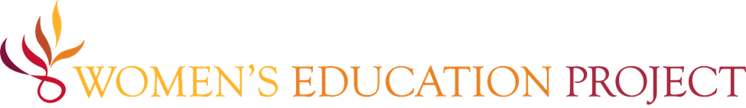

WEP Program Overview – For Survey Participants

Why is this survey important?
We are conducting a preliminary needs assessment to ensure WEP’s program remains relevant, inclusive, and scalable. Your honest responses will help us improve delivery, mentorship, partnerships, and alumnae engagement.
Together, we can co-create a leadership movement that equips thousands of young people across India—and beyond—to thrive.

About WEP
Founded in 2002, Women’s Education Project (WEP) equips young women (15+ age group) to become leaders and pursue careers of their choice. Its core program is the Leadership Academy and the Collaboration Lab, a training and resource center.
WEP-India, a registered public charitable trust based in Bangalore, leads on-the-ground implementation of the Leadership Academy and houses the Collaboration Lab to support and strengthen regional partners. Together, WEP and WEP-India form a mission-driven, partnership rooted in shared vision and sisterhood.
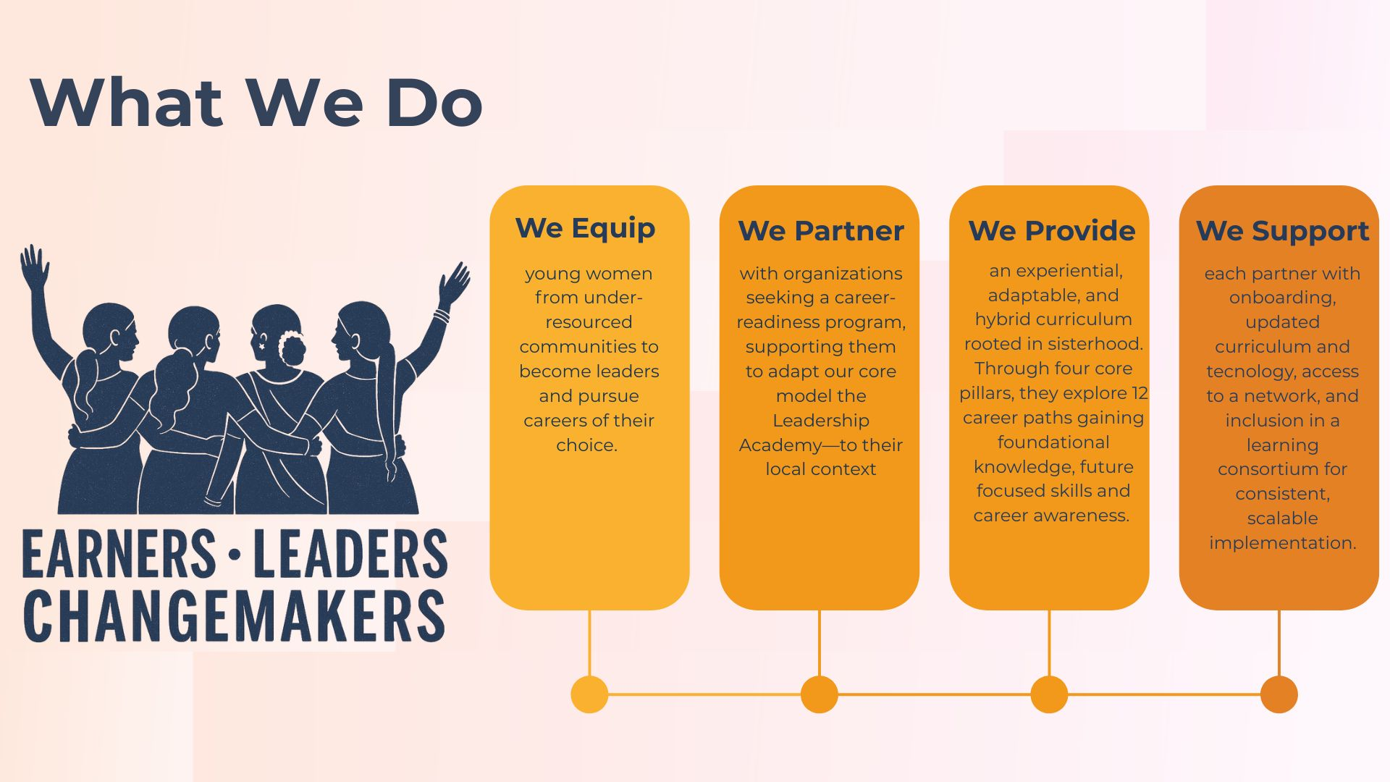

About the Leadership Academy
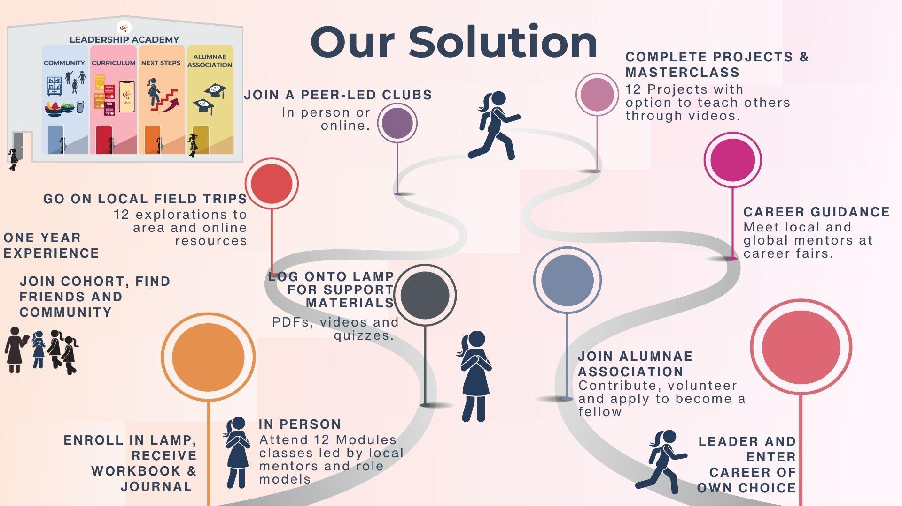
The Leadership Academy is a safe and supportive learning program designed to help young women build confidence, develop career skills, and become changemakers in their communities.
It is delivered through a hybrid model that includes in-person sessions/workshops and a mobile platform called LAMP (Leadership Academy in My Pocket).
Key Features:
- A community for learning, peer support, and growth
- Mobile-based curriculum (LAMP) for life skills, leadership, and career readiness
- Mentoring, exposure to careers/career readiness program
- Alumnae network for continued support, fellowship, and giving back

What is the Collaboration Lab?
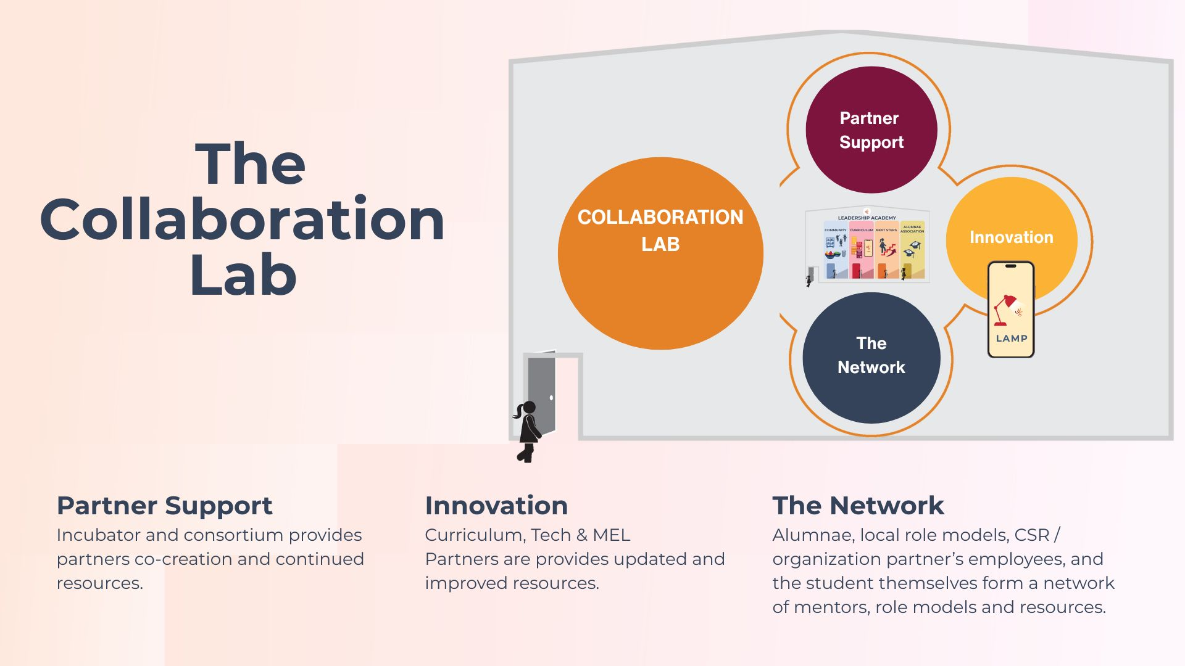
The Collaboration Lab is WEP’s engine for scale. It helps NGOs and institutions adapt and run the Leadership Academy in their own communities.
It includes:
- Training and support for partner organizations
- Curriculum and tech development
- A growing mentor network
- Monitoring, Evaluation, and Learning (MEL)

What is LAMP (Leadership Academy in My Pocket)?
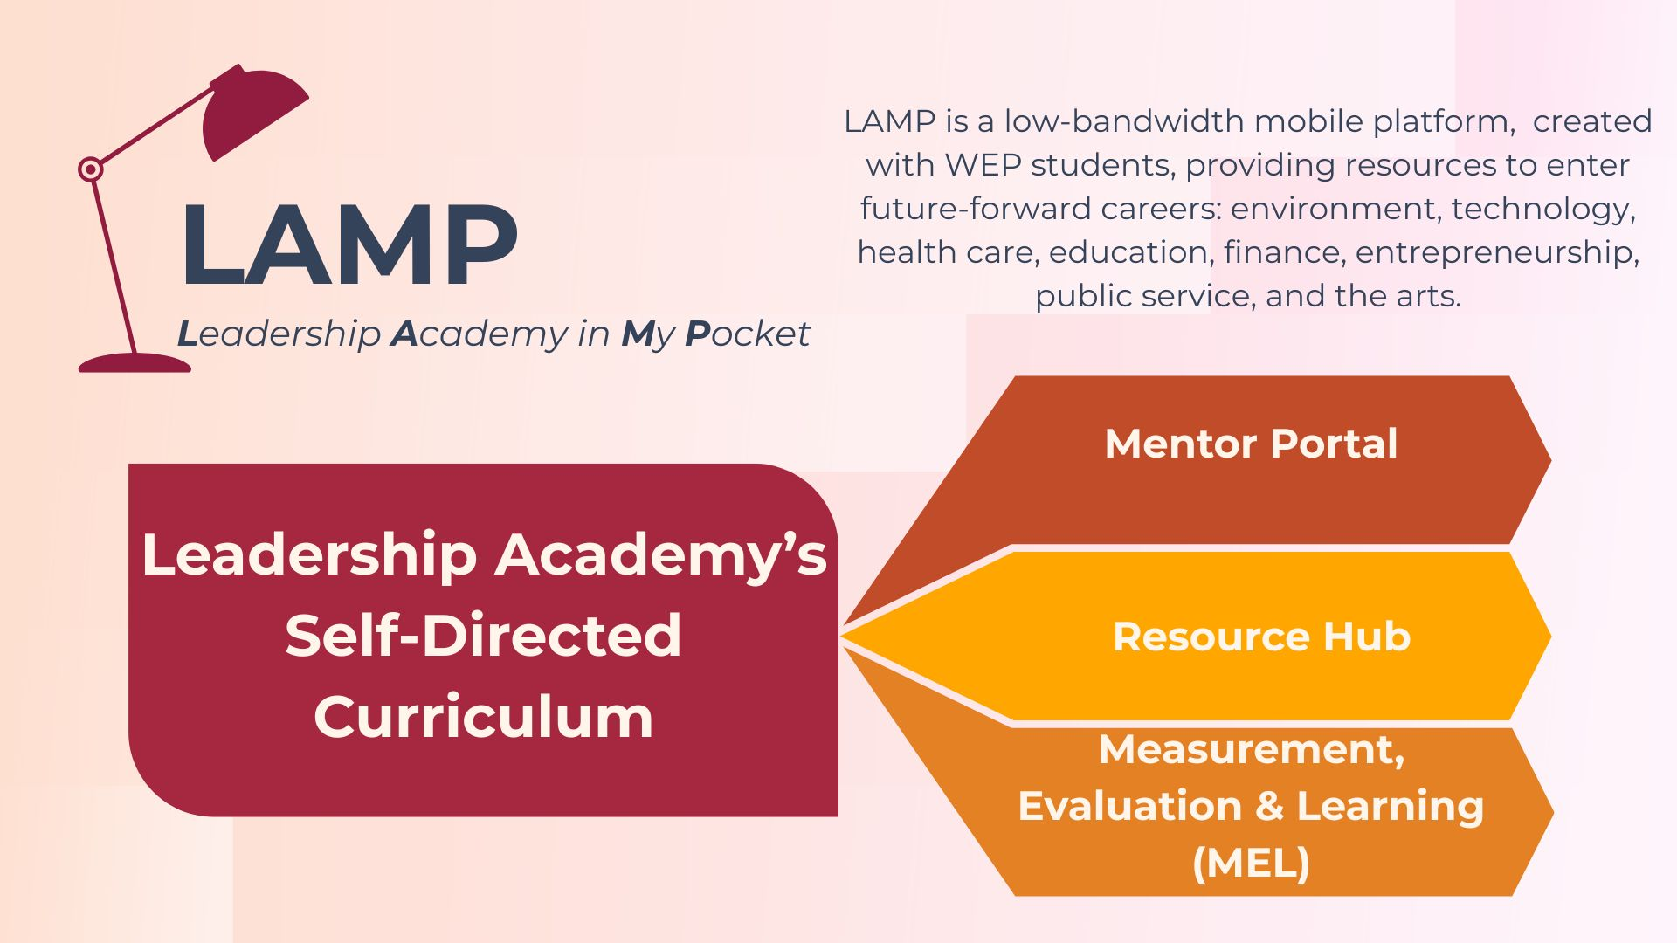
LAMP is WEP’s mobile-first platform that digitizes the Leadership Academy’s 12-module curriculum, giving young women access to career-readiness and leadership training anytime, anywhere, even in low-bandwidth settings.

What is the Alumnae Fellowship?
The Alumnae Fellowship is one of the core pillars of WEP’s scalable model, creating a sustainable cycle of leadership and mentorship. After completing the Leadership Academy, graduates can apply to return as paid Fellows, taking on roles such as mentors, club coordinators, facilitators, and Collaboration Lab support. Fellows guide students, lead peer-learning groups, conduct outreach, and help strengthen WEP programs, while continuing their own growth.
Designed to align with each Fellow’s education or career path, the Fellowship builds skills in leadership, facilitation, communication, and digital learning. In return, Fellows receive stipends, training, certification, and access to WEP’s alumnae network, scholarships, jobs, and exclusive events. This model positions alumnae as relatable role models, ensuring that each generation of young women uplifts the next.

Next Step Partners
The Next Step Partners are organizations, institutions, and individuals who provide career, education, and mentoring opportunities to WEP alumnae after they graduate from the Leadership Academy. They are an integral part of WEP’s scaling and sustainability strategy, ensuring that young women have tangible avenues for growth beyond the program.

Core Purpose
- Extend the impact of WEP’s Leadership Academy by creating clear post-program pathways.
- Help alumnae apply their skills in real-world settings, bridging leadership training to career readiness.
- Build a networked ecosystem that strengthens WEP’s long-term impact and alumni community.
- Co-create curriculum for the 12 Leadership Academy modules, drawing on partners’ domain expertise.
- Provide expert mentors who guide WEP’s students and alumnae, strengthening their learning and career journeys.

